Linux command for middle level users

Find command is used to Search for files in the given directory



**Note:** The `**-name**‘ option makes the search case sensitive. You can use the `**-iname**‘ option to find something regardless of case.

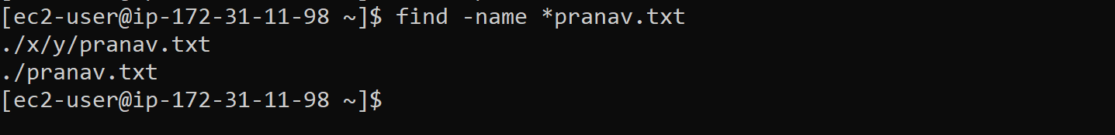

Wildcard * is used to search for all the pranav.txt file in all locations

Grep Command

The ‘**grep**‘ command searches the given file for lines containing a match to the given strings or words.



Ignore word case and all other combination with ‘**-i**‘ option.

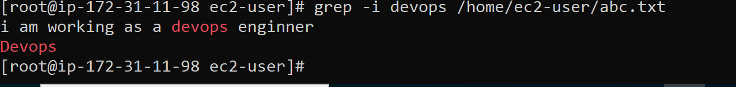

-r for searching recursively

-c for the count of the word

-w for the word

-color for the colored output

MAN command(manual page)

Man command is used for documentation of any command

Man <command for fetching documentation>

Command ps(process state)

**ps** (**Process**) gives the status of running processes with a unique **Id** called **PID**.

-A is used to list all the process with process ID.

Here ‘**ps**‘ is pipelined with ‘**grep**‘ command to find customised and relevant output of our need.

Kill command is used to kill the process



We can use pkill command to use process name.

The ‘whereis‘ command is used to locate the Binary, Sources and Manual Pages of the command. 

**Note**: This is useful to know where the binaries are installed for manual editing sometimes

SERVICE Command

It use to start stop or restart a service

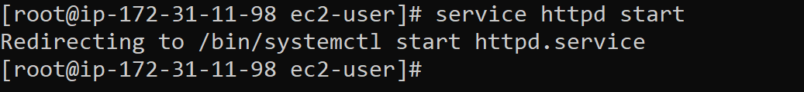

Command df

Report disk usages of file system. Useful for user as well as System Administrator to keep track of their disk usages. ‘**df**‘ works by examining directory entries, which generally are updated only when a file is closed.

DU command

Estimate file space usage. Output the summary of disk usages by ever file hierarchically, i.e., in recursive manner.

**Note**: ‘**df**‘ only reports usage statistics on file systems, while ‘**du**‘, on the other hand, measures directory contents.

Rm Command

The command ‘**rm**‘ stands for remove. **rm** is used to remove files (s) and directories.

ECHO command

CMP COMMAND

Cmp command is used to compare two files

WGET COMMANDS

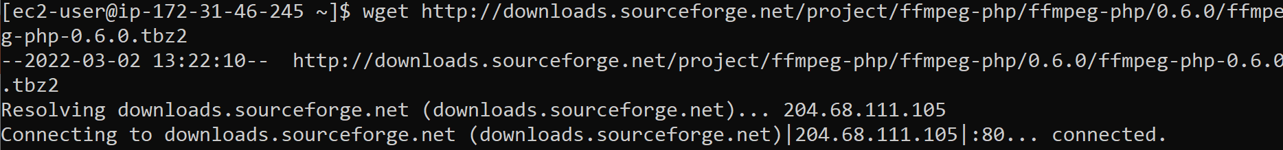

GCC COMMAND

